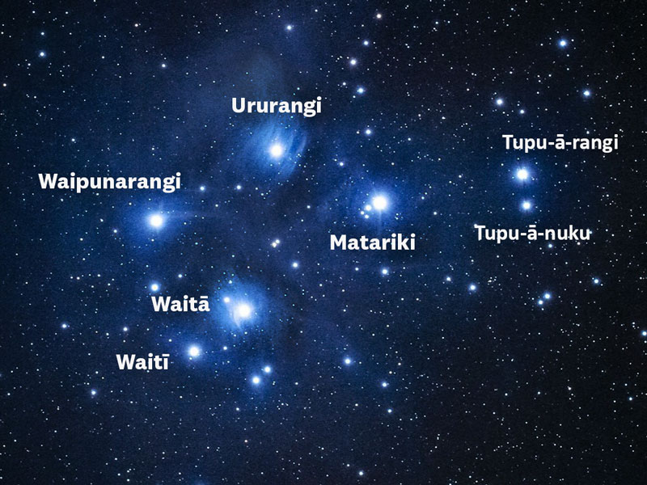
Matariki star cluster. Courtesy of Fraser Gunn www.astroimage.co.nz
What is Matariki?.
Matariki is the Māori name for the star cluster known as the Pleiades. Traditionally for Māori when it appeared just before dawn in late May or early June, it signalled the start of the Māori New Year. For some tribes, the rising of Puanga (Rigel in Orion) signals the start of the New Year.
Traditionally, it was a time for remembering the dead, celebrating new life and planting new crops. In the 21st century, observing Matariki has become popular again as a cross-cultural celebration. Kites, kai, balloons and fireworks help mark the occasion.

When is Matariki?
Different tribes celebrated Matariki at different times. For some it was when Matariki rose in May/June. For others it was celebrated at the first new moon, or full moon, following the rising of Matariki. In the 21st century it is the new moon following the rising of Matariki that signals the New Year.
Iwi across Aotearoa celebrate Matariki at different times according to when its return is observed from their rohe (area). To some iwi the new year in mid-winter was signalled by the dawn rising of Matariki (the Pleiades), while to others it was the rising of Puanga (Rigel in Orion). Matariki or Puanga can be seen pre-dawn in the north-east of the sky, just above the horizon from mid-June to early July.
Read Te Ara's blog - A beginner's guide to finding Matarki.
Because Māori follow the Māori lunar calendar, not the European calendar, the dates for Matariki change every year. In 2019, the Matariki cluster will set on 27 May and return from 25-28 June. The Matariki period is 25 June-3 July. See Te Wānanga o Aotearoa’s list of Matariki dates for the next 10 years.
More detailed information about Matariki can be found on the following websites. Teachers need to be aware that different Iwi have different stories, so here are some resources.
Te Ara website : Matariki – Māori New Year
NZHistory website : Matariki
Te Papa's Matariki webpages including an activity book – this is for 5-10 year olds
Te Wānanga o Aotearoa's Matariki Resources
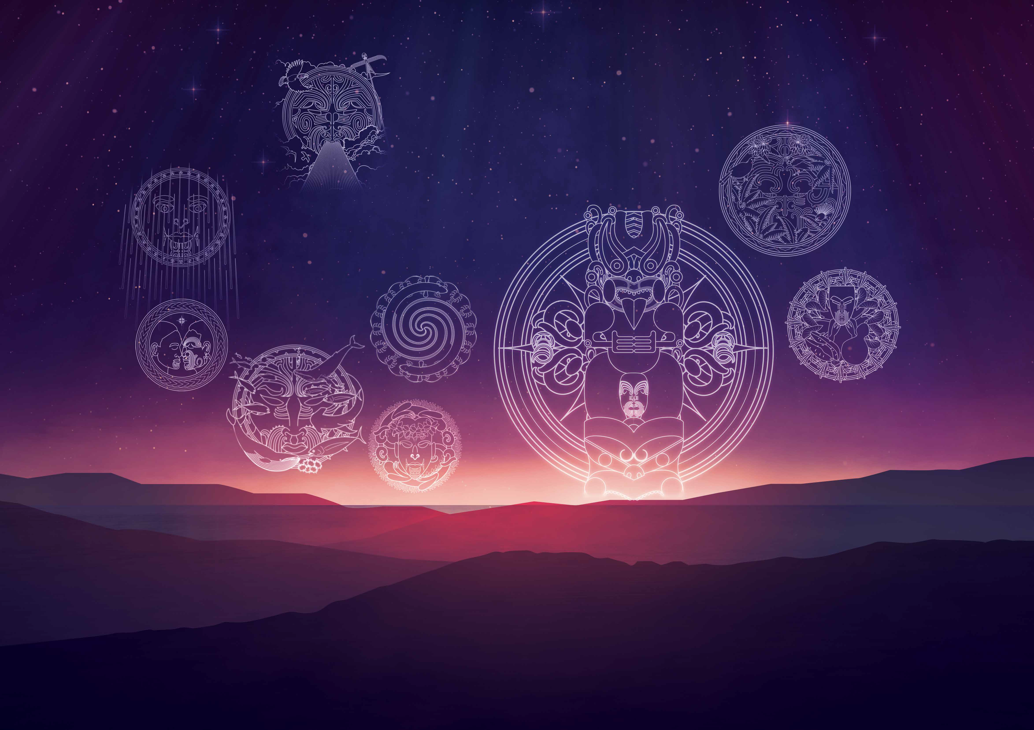
Kiwi Families - simple ways to celebrate Matariki

6 simple ways to celebrate Matariki with your family
There are lots of ways you can celebrate Matariki with your family, and in doing so, start your own family traditions. Some ideas to get you started include:

1. A Family Feast
Make Matariki a time when the whole family gets together to feast and give thanks. It may be a nice opportunity to explore traditional Māori food like hangi and rewena, or Māori bread. Our star-shaped sugar cookies will go down well for desert.

2. A New Harvest
Use Matariki as a time to clear the winter vegetables, and prepare your vegetable garden for the new planting. It could become a family tradition to do the gardening altogether – at least for one day of the year.

3. Tree Planting
Contact your local Department of Conservation to find out if there are any regeneration projects happening in your area. Organise to plant a tree on Matariki, or better still, get together with a group of friends and plant several.

4. Sleep Under the Stars
Spend a night sleeping under the stars (or under a tent!), and tell your own family stories. You may want to talk about family memories, or create goals for the coming lunar year.

5. New Years Resolutions
Most of us create New Years resolutions in January, but by the time June rolls around they are long forgotten. Why not use Matariki as a time to renew your resolutions.

6. Attend a Matariki Event
For more great ideas on how to spend Matariki with your friends and family, check out our Fresh ideas for celebrating Matariki with your Family.

How to find Matariki (the Pleiades)
The pre-dawn rise of Matariki, also known as the Seven Sisters or Pleiades, traditionally signals the Māori New Year under the maramataka, or lunar calendar.
In general, celebration of Matariki starts when the first new moon can be seen following the pre-dawn rise of Matariki. The new moon can be seen on 5 June this year, and celebrations kick off from 6 June. Traditionally, Matariki was both a time to commemorate those who had passed on, and celebrate a time of plenty when stores were abundant from horticulture, hunting and fishing.
For some iwi, Puanga (Rigel), rather than Matariki, was the signal for the new year. For instance, Whanganui iwi are having a Puanga festival. In the South Island it is Puaka (which is Puanga in Ngāi Tahu dialect) that heralds the new year.
Whether you’re celebrating Matariki or Puanga, here’s an easy guide to try to find the stars.
Matariki is found low on the horizon in the north east of the sky. Try looking here between 5.30 a.m. and 6.30 a.m.
The pot
1. First find the pot (the bottom three stars of the pot are also called Tautoru, or Orion’s Belt). To find Puanga (Rigel) look above the pot until you see the bright star. To find Matariki, keep going.
2. To the left of the pot, find the bright orange star, Taumata-kuku (Alderbaran).
3. Follow an imaginary line from Tautoru (the bottom three stars of the pot), across to Taumata-kuku and keep going until you hit a cluster of stars.
4. That cluster is Matariki. If you have good eyes you should be able to pick out individual stars. If it looks fuzzy, look just above or just below and the stars will be clearer.
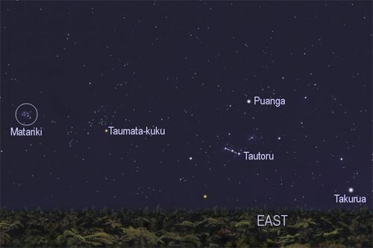
Matariki in the night sky
This picture, from AstronomyNZ, shows the relative position of Matariki (Pleiades) to Taumata-kuku (Alderbaran), Tautoru (Orion’s belt), Puanga (Rigel) and Takurua (Sirius).

Matariki and the six sisters - https://www.tepapa.govt.nz/discover-collections/read-watch-play/maori/matariki-maori-new-year/whare-tapere/six-sisters

Te ono o Matariki
There are many legends about the star cluster Matariki. One of the most popular is that the star Matariki is the whaea (mother), surrounded by her six daughters, Tupu-ā-nuku, Tupu-ā-rangi, Waipunarangi, Waitī and Waitā, and Ururangi.
Matariki and her daughters journey across the sky each year to visit their tupuna wahinewahine great grandmother, PapatūānukuPapatūānuku Mother Earth.
During this visit, each of the stars help Papatūānuku to prepare for the year to come, using their unique qualities or gifts to bring maurimauri life force or energy to her different environments. Whilst spending time with their kuiakuia grandmother, they also learn new skills and gain new knowledge from her, which they guard and pass on to others.

Tupu-ā-nuku
Tupu-ā-nuku is the eldest of Matariki’s daughters. She spends her time with Papatūānuku tending to plants. She pays special attention to making sure they have everything they need to grow big and strong so they can produce kaikai food, rongoārongoā medicine, and kākahukākahu clothing materials.
When we see her shining we are reminded that we all have our own special time and place, and to spend time growing our pūkengapūkenga strengths, as well as that of our friends.
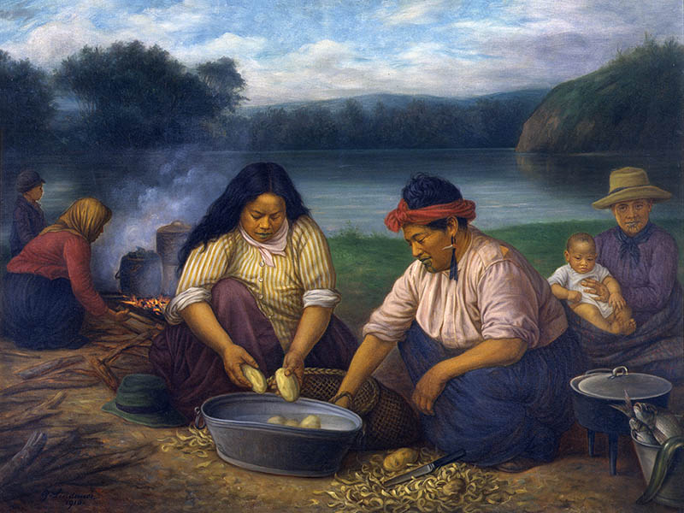

Tupu-ā-rangi
Tupu-ā-rangi loves to sing. Papatūānuku takes her to sing for te wao nuite wao nui the great forests, and all the children of Tānemahuta. Her beautiful voice revives the forest and all the other creatures, including the manumanu birds , and mokomokomokomoko lizards . They share their waiatawaiata song , which fills the world with joy.
Tupu-ā-rangi learns these songs and holds them close to her heart. We learn from her the importance of sharing our gifts with others, and appreciating those shared with us.
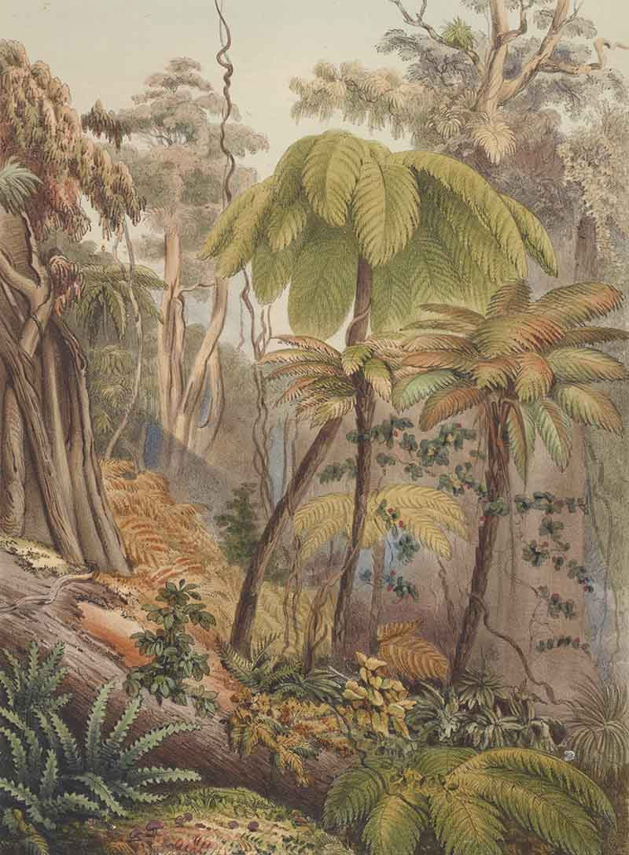

Waipunarangi
Waipunarangi accompanies her grandmother to the waters – the oceans, lakes and rivers – where she prepares the children of TangaroaTangaroa god of the sea to feed the people.
Papatūānuku also teaches her about how the water that spills down from RanginuiRanginui the sky father collects together to provide drinking water for the people, animals and plants.
She also watches how the water is evaporated by the heat of Tama-nui-te-rāTama-nui-te-rā the sun into the clouds that cloak Ranginui, so that may rain once again.
Waipunarangi knows that if you give to others, all that kindness will come right back to you, and it is this lesson that she shares with us.

Waitī and Waitā
Waitī and Waitā are Matariki’s twins. Papatūānuku knew that they would be able to care for the smallest and fastest of creatures – because they too know about being a team.
When insects work together, they can they can do amazing things. Ngā pīNgā pī beesNgā pī ees, for example, pollinate all the flowers so that the plants grow, and we have air to breathe. Ngā pōpokorikiNgā pōpokoriki ants build huge, complicated tunnel cities underneath the ground, and carry many times their body weight.
When we see these two stars in the sky, we are encouraged to join in and support each other.
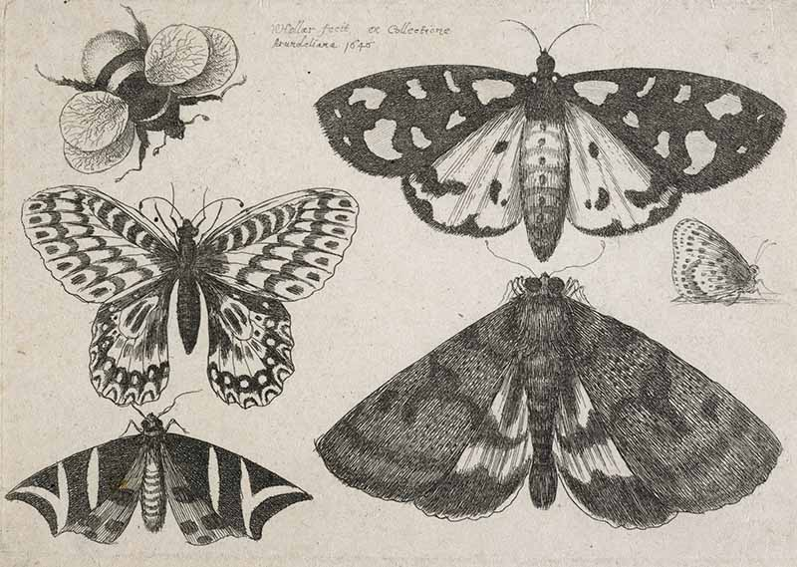

Ururangi
Ururangi enjoys racing all of her sisters to get to her kuia first. She claims the best spot on her grandmother’s lap and wraps herself in her arms, settling in for her favourite stories. Her tenacity and excitement, along with the awhiawhi hug and her arohaaroha love, helps Papa to get into the right mood after the cold and darkness of takuruatakurua winter, to prepare with her older mokopunamokopuna grandchildren.
Ururangi reminds us that a good attitude is always key to success.

Matariki
But what about Matariki you may ask? Well, she's doing what all good mothers (and other caregivers) do – watching over and helping out her tamarikitamariki children. With her support, encouragement, and supervision, they will be able to do their very best.

Matariki - https://nzhistory.govt.nz/classroom/matariki/social-studies-activities

Page 4 – Matariki teaching activities

Measuring time
- Why do we bother to measure time in days, months and years?
- Why are there so many ways of measuring time? In a paragraph, of between four and six lines, explain why there are so many different calendars in the world.
- What are at least two things that these calendars seem to have in common?
- What are at least two major differences between the different calendars described?
- According to the Muslim and Jewish calendars, what year were you born in?
- Wouldn't it be simpler if there was just one, single calendar that applied to everyone? You could consider this as a class debate with teams of three debating the pros and cons of the concept. Normal debating rules apply. So that everyone can be involved, small groups could help prepare arguments that are then presented by selected speakers. Alternatively, each student could take a position on this statement and give their own view with supporting arguments.

Matariki: The Maori New Year
Refer to the material on Matariki available from Te Ara to help you complete these activities.
- In Māori what does Matariki mean?
- What are some of the explanations given for the origins of the cluster of stars associated with the Māori New Year?
- In traditional times what did Māori acknowledge with the arrival of Matariki?
- How did Matariki affect Māori farming?
- What role do kites (pakau) play in Māori celebrations of Matariki?

Celebrating Matariki
At the beginning of the 21st century Matariki celebrations were revived. Festivals organised to celebrate Matariki have grown in size: a Hawke’s Bay festival attracted 500 people in 2000. Three years later 15,000 people came. Te Rangi Huata, who helped organise these festivals in Hastings, believes that Matariki is becoming more popular because it celebrates Māori culture and in doing so brings together all New Zealanders. He compares it to the American holiday of Thanksgiving or Halloween ‘except it’s a celebration of the Māori culture here in (Aotearoa) New Zealand. It’s New Zealand's Thanksgiving.’
The increasing popularity of Matariki has led some to suggest that it should replace Queen's Birthday as a public holiday. What do you think?
Imagine you are an adviser for the Department of Labour. This government department is responsible for administering the Holidays Act 2003. You have been asked to write a paper for the minister of labour and the prime minister. They will use this paper to give Cabinet information to help it discuss the benefits and disadvantages of replacing the existing public holiday of Queen’s Birthday with a day to celebrate Matariki.
1. Your task is to:
a. Outline at least three advantages for New Zealand if the existing public holiday of Queen’s Birthday was replaced with a day to celebrate Matariki. You must explain why you believe this decision would be of benefit to New Zealand. For instance:
One advantage is that a public holiday to celebrate Matariki would be an acknowledgement of New Zealand’s first settlers.
b. Outline at least three disadvantages for New Zealand if the Queen’s Birthday holiday was replaced by Matariki. You must explain to the ministers why you believe this decision would be bad for New Zealand. For instance:
Other ethnic groups in New Zealand might demand that their New Year should also become a public holiday, such as Chinese New Year. Where will it stop?
c. In no more than 150 words, you must advise your ministers which argument to support and the reasons why you believe this action should be taken, i.e. to replace Queen’s Birthday with Matariki or not. They will be expecting you to give them answers to some possibly tricky questions raised by those who might disagree, so consider this in your final advice.
2. Alternatively:
You could use the issue as a topic for an editorial that might appear in your local newspaper.
It is the start of Matariki and your newspaper is presenting a feature looking back at the history of the Māori New Year and its place in our national calendar. Write an editorial, of no more than 200 words, expressing your views on whether or not the time has come to replace the Queen’s Birthday public holiday with Matariki. Consider issues like the general history of these two events and whether it is now time to develop something new to move New Zealand through the 21st century. Or is it more important to retain traditional links with our past?
Have a look at some examples of editorials to get a sense of the style of writing.
These can be read out to the rest of the class or published as a class booklet that all can read. If your school has a school-wide focus for Matariki, a selection of these arguments could be presented at a school or syndicate assembly.
3. Better yet, try a class debate. You could consider this as a class debate with teams of three debating the pros and cons of the idea. Normal debating rules apply. Small groups could help prepare arguments that are then presented by selected speakers to ensure all can be involved.

A school-wide celebration of Matariki
You and your classmates could organise a school-wide celebration of Matariki. As a class you could brainstorm ideas for activities the school could participate in. For instance, you could organise a kite festival, or design posters and art work that acknowledge and promote Matariki for display around the school. Another possibility could be drama performances that explore some of the stories and themes associated with Matariki.

Matariki and your community
Many communities run festivals and events to celebrate Matariki. Find out what’s happening in your community. Local newspapers, information centres and libraries are good places to start.

Storyboarding Matariki
There are a number of Māori legends associated with Matariki. Present one of these legends as an illustrated story. Your presentation should be no bigger than A3.

Ministry of Education materials:
Building Science Concepts, Volume 27 – Exploring Space: Discovering our place in the Universe
Building Science Concepts, Volume 28 – The night sky: Patterns, observations, and tradition

Sky Globe - Star Chart of the Entire Night Sky – This takes some time and effort but the end result is awesome, really for years 7-8 but a good year 5-6 class probably could get this completed.
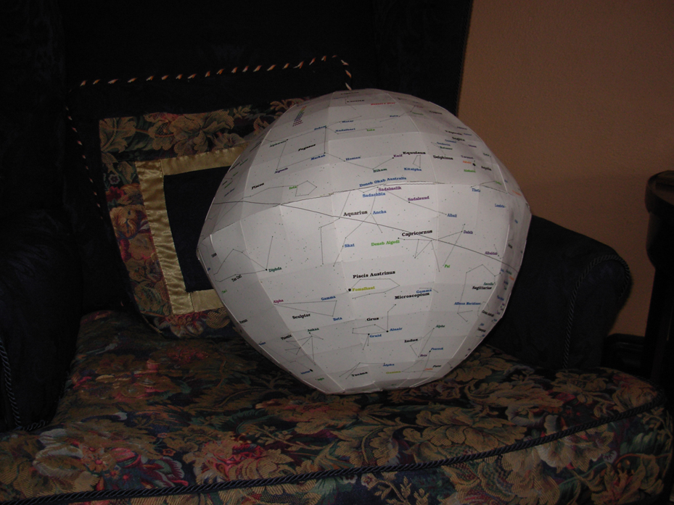
The Sky Globe is constructed from 24 gores, 12 for the Northern Hemisphere and 12 for the Southern. They were printed on 12 sheets of standard size card stock. The Constellations names are printer in black and the star names are colored to indicate their distance from Earth. There are 88 Constellations and 291 stars. These "landmarks" are visible with the naked eye at various times throughout the year.
The 12 image files (150 dpi) can be seen in the directory /gores_jpg. Download then one at a time or download gores_jpg.zip for all of them. The Photoshop PSD files are also available in the directory /gores_psd for downloading. The assembly instructions are in the directory /guide.
All material may be used, transferred, replicated and duplicated in any form by any sentient being.
This entire work may be downloaded for offline use or to be mirrored on the Web - Skyglobe.zip

Assembly - Please read the steps before cutting, folding, taping and gluing.

A. Gores face up:
1. Print each page on 8 1/2 by 11 card stock without resizing the image.
2. The tabs have the letter "N" or "S" on them. Do not cut them off.
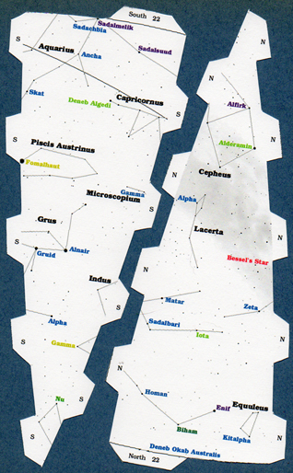
3. Each gore has a tab at the equator labelled with its Right Ascension.
4. Cut off the unlabelled equatorial area at the equatorial line. It is not a straight line.
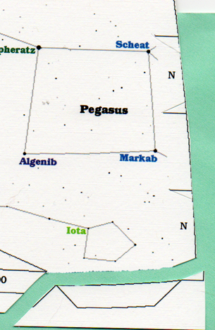
5. Cut off the crop marks so that each "N" and "S" tab is a trapezoid slanting 6 degrees inward on the short sides.
6. Using a straightedge, cut between the tabs. The line between tabs is slightly curved, but I lack the skill to cut freehand.
7. The crop marks at the poles do not meet each other. There is a tab on one side and a straight cut on the other.
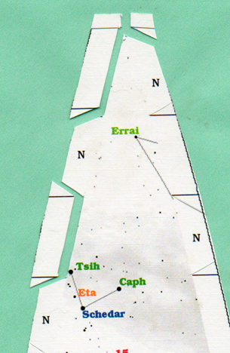

B. Gores face down:
8. Using a straightedge, very slightly fold the tabs inward. Do Not Fold the tab at the Equator.
9. Line up the straightedge from the bottom vertex of one tab to the top vertex of the tab on the opposite side of the gore. It is perpendicular to a line from pole to equator. Fold the gore a small amount.
10. The tab at the Equator has a curved base line. Using a straightedge, slightly fold on a line intersecting the base vertices of the gore.

C. Tapping and Gluing the Gores
11. No real best method starting point.
a. Select two adjacent gores, Attach together at a mid-latitude. Attach at the pole then equator.
b. Attach at other tabs. I used tape inside worked in spots of glue from the outside.
c. Complete one Hemisphere in this manner.

D. This is a little tricky:
12. The base of the equatorial tab is a curved line. Apply some glue to the tab labelled "North". As you affix the North Gore to the South Gore the paper will bend. Apply glue to the tab labelled "South" and finish the attachment resulting in a nice straight Equatorial line.
a. Attach one gore at the equator.
b. From section C-11 repeat steps a. and b. and attach at the equator as progress is made around the Hemisphere.

E. Taping and Gluing the Last Gore
13. Put tape on some, but not all of the remaining tabs of the nearly completed globe.
14. Attach the last gore at the equator.
15. Work the tabs into the interior of the globe.
16. I slid a butter knife into the globe where a tab had no tape to secure the taped tabs on the opposite side of the gore.
17. I worked in a little glue onto the untapped tabs and gently pressed the remaining seam together.

