Deep impact

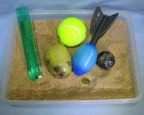
You will need these materials.
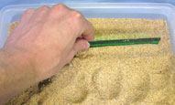
Fill the tray with sand and smooth the surface with the ruler.
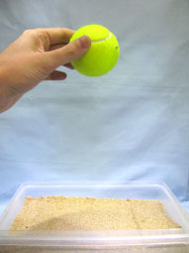
Drop a ball into the surface of the sand. Repeat using different drop heights and different balls. What do you observe?

You will need
• Sand
• Tray
• Ruler
• Balls of different sizes, shapes and materials

What to do
1. Fill the tray with sand. Use the ruler to smooth over the surface.
2. Take one of the balls and drop it into the sand from a height of about 30 centimetres. Observe the mark it makes.
3. Drop the same ball, but from a greater height (about 50 centimetres). Compare this mark to the first one.
4. Repeat with different balls from different heights, and compare the marks that they leave behind.
5. Instead of just dropping the ball, try throwing a ball so that it hits the sand at an angle. What does this mark look like?

What’s happening?
The impacts of the balls hitting the surface of the sand leave marks. The diameter, depth and shape of a mark depend on a few different factors. By dropping a ball from the greater height, the ball has a higher speed when it hits the sand. This higher speed means the ball has more kinetic energy, which can be transferred into the sand, creating a larger mark.
Mass also plays a role. Heavier balls will leave deeper marks than lighter ones when they are dropped from the same height. Again, this is because a heavier ball has more kinetic energy.
The shape of the mark depends on the shape of the projectile, and the angle at which it hits the surface. Dropping a spherical ball at right angles to the surface usually leaves a fairly regular, circular mark. When it hits the surface at an angle, the shape is different.

Applications
Asteroids are rocky bodies from outer space. While they usually orbit the Sun, sometimes an asteroid will collide with the Earth. Asteroids come in many different sizes, and they often leave craters where they hit the Earth’s surface. By studying the size, shape and geology of impact craters, geoscientists can learn more about the objects that caused them.
It is a widely accepted theory amongst paleontologists that a comet or asteroid colliding with the Earth played a significant part in the extinction of the dinosaurs. The craters that we can see on the surface of the Moon were also caused by the impact of asteroids on the lunar surface.

